VE (Victory in Europe) Day
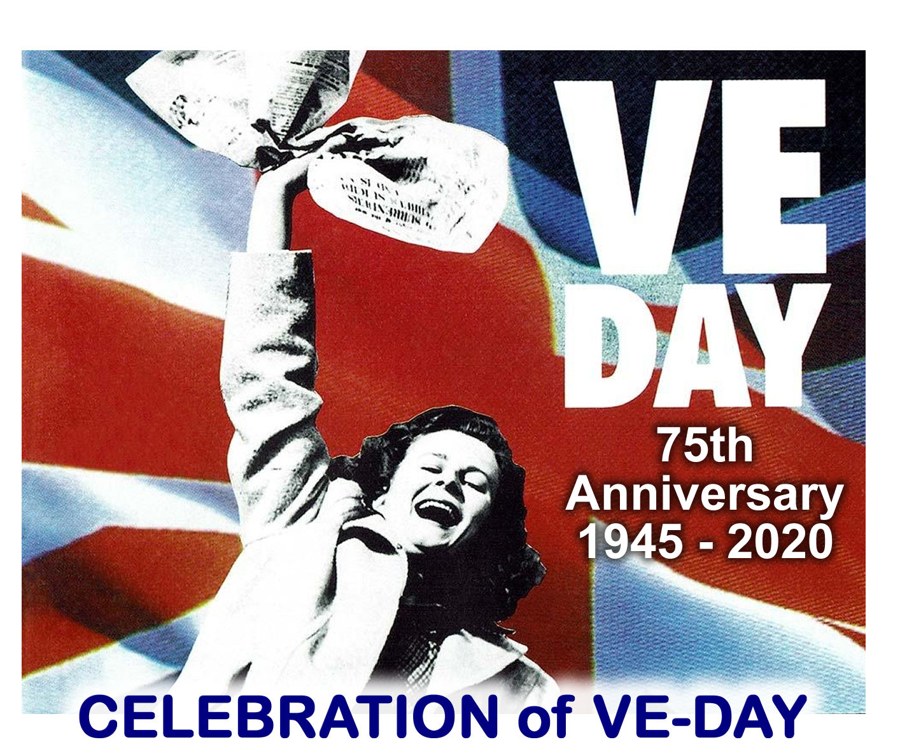
8 May 1945 – VE (Victory in Europe) Day – was one that remained in the memory of all those who witnessed it. It meant an end to nearly six years of a war that had cost the lives of millions; had destroyed homes, families, and cities; and had brought huge suffering and privations to the populations of entire countries.
Millions of people rejoiced in the news that Germany had surrendered, relieved that the intense strain of total war was finally over. In towns and cities across the world, people marked the victory with street parties, dancing and singing.
But it was not the end of the conflict, nor was it an end to the impact the war had on people. The war against Japan did not end until August 1945, and the political, social and economic repercussions of the Second World War were felt long after Germany and Japan surrendered.
Here's what you need to know about VE Day and how it was marked in Britain and around the world.

Germany signed an unconditional surrender
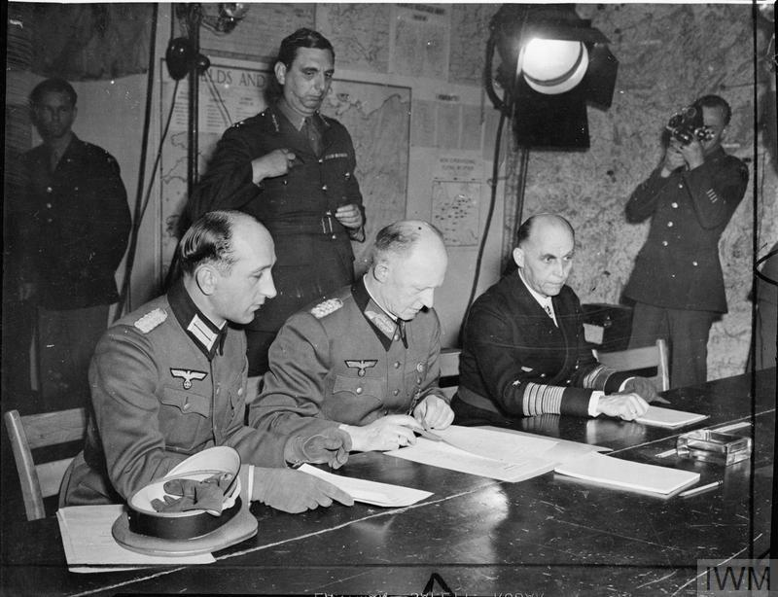
With Berlin surrounded, Adolf Hitler committed suicide on 30 April 1945. His named successor was Grand Admiral Karl Dönitz. During his brief spell as Germany’s president, Dönitz negotiated an end to the war with the Allies – whilst seeking to save as many Germans as possible from falling into Soviet hands.
A German delegation arrived at the headquarters of British Field Marshal Bernard Montgomery at Lüneburg Heath, east of Hamburg, on 4 May. There, Montgomery accepted the unconditional surrender of German forces in the Netherlands, northwest Germany and Denmark. On 7 May, at his headquarters in Reims, France, Supreme Allied Commander General Eisenhower accepted the unconditional surrender of all German forces. The document of surrender was signed on behalf of Germany by General Alfred Jodl and came into effect the following day.
Soviet leader Josef Stalin wanted his own ceremony. At Berlin on 8 May, therefore, a further document was signed – this time by German Field Marshal William Keitel. Dönitz’s plan was partially successful and millions of German soldiers surrendered to Allied forces, thereby escaping Soviet capture.

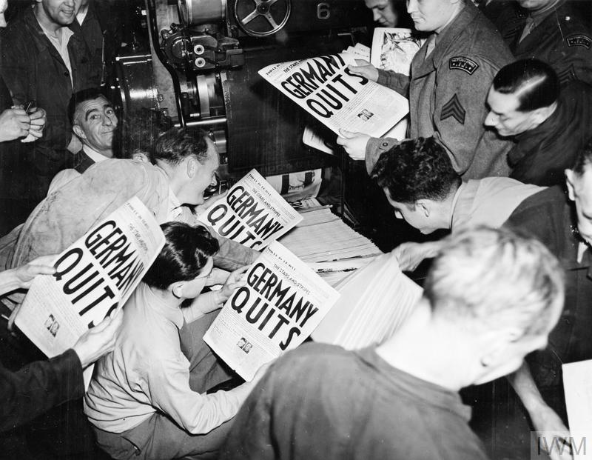
Germany’s surrender was not a surprise
The news of Germany’s surrender was not surprising. It had been anticipated for some time and people across Britain were on standby to start celebrating the end of the war.
The announcement that the war had ended in Europe was broadcast to the British people over the radio late in the day on 7 May. The BBC interrupted its scheduled programming with a news flash announcing that Victory in Europe Day would be a national holiday, to take place the following day. Newspapers ran the headlines as soon as they could, and special editions were printed to carry the long-awaited announcement. The news that the war was over in Europe soon spread like wildfire across the world.

Some people celebrated early
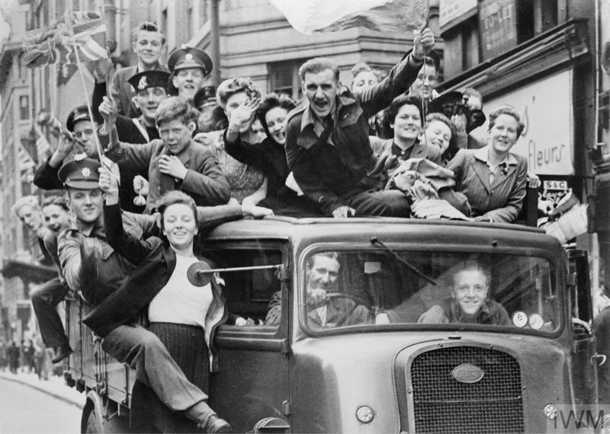
Many people in Britain didn't wait for the official day of celebration and began the festivities as soon as they heard the news on 7 May. After years of wartime restrictions and dangers – from food and clothes rationing to blackouts and bombing raids – it was understandable how eager they were to finally be able to let loose and enjoy themselves. Colourful bunting and flags soon lined the streets of villages, towns and cities across Britain. On the eve of VE Day, bonfires were lit, people danced and the pubs were full of revellers.

VE Day was a national holiday
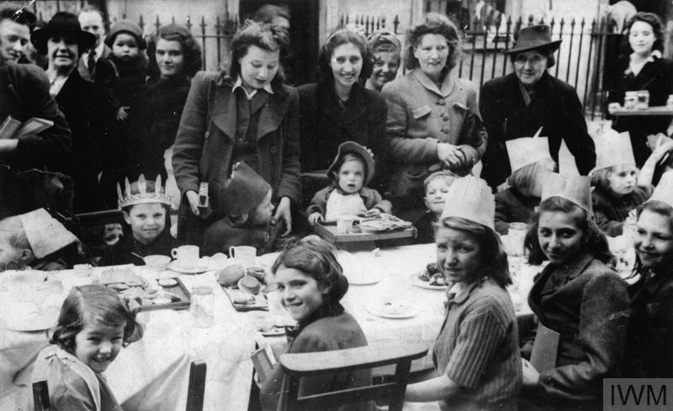
A national holiday was declared in Britain for 8 May 1945. In the morning, Churchill had gained assurances from the Ministry of Food that there were enough beer supplies in the capital and the Board of Trade announced that people could purchase red, white and blue bunting without using ration coupons. There were even commemorative items hastily produced in time for the celebrations, including ‘VE Day’ mugs. Some restaurants had special ‘victory’ menus, too.
Various events were organised to mark the occasion, including parades, thanksgiving services and street parties. Communities came together to share the moment. London’s St Paul’s Cathedral held ten consecutive services giving thanks for peace, each one attended by thousands of people. Due to the time difference, VE Day in New Zealand was officially held on 9 May. The country’s leadership wanted to delay the national holiday until peace in Europe had been announced by Winston Churchill. New Zealanders therefore had to go to work on 8 May and wait until the following day to celebrate. In the Soviet Union, too, VE Day was on 9 May due to the different time zones.

Churchill addressed the nation
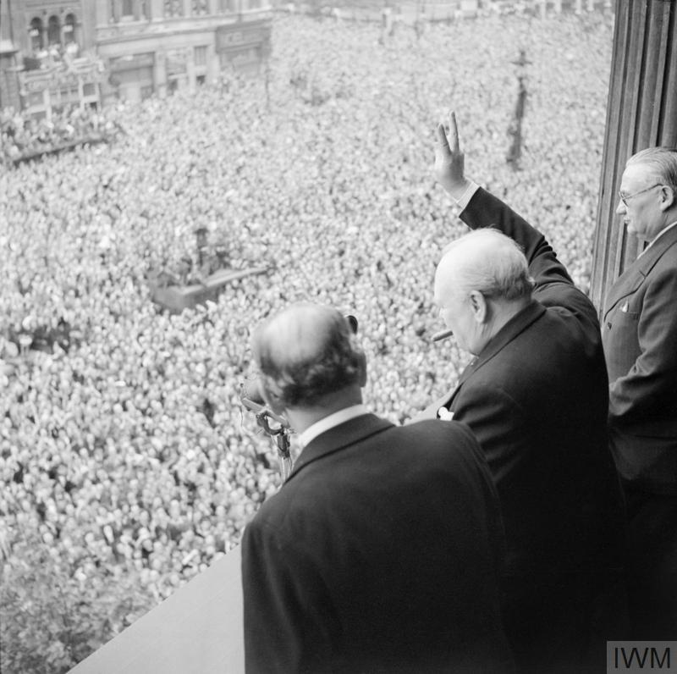
Winston Churchill was the man of the hour on VE Day. Britain’s Prime Minister had been a major driving force behind the Allies’ victory over Nazi Germany and, now that peace had come, the British people were keen to celebrate it with him.
At 3pm on VE Day, Churchill made a national radio broadcast. In it, he announced the welcome news that the war had ended in Europe – but he included a note of caution, saying: ‘We may allow ourselves a brief period of rejoicing; but let us not forget for a moment the toil and efforts that lie ahead.’ He knew that the war was not over: Japan still had to be defeated. Later on, Churchill appeared on the balcony of the Ministry of Health building in central London and gave an impromptu speech. Huge, cheering crowds gathered below and he declared, 'This is your victory.' The crowd shouted back, 'No – it's yours!' Despite Churchill’s crucial wartime role, the British public did not vote him back into power in the July 1945 General Election. Instead, Clement Attlee’s Labour government had control of the country in the immediate post-war years. For Churchill, nothing would match his period as wartime prime minister – he later wrote that everything afterwards was 'all anti-climax'.

The Royal Family took part in the celebrations
The British Royal Family also played a central role in London's victory celebrations. Huge numbers of people surged down The Mall to Buckingham Palace, where King George VI, Queen Elizabeth and their daughters, Princess Elizabeth and Princess Margaret, soon appeared on the balcony to wave to the cheering crowds.
In total, the King and Queen made eight appearances on the balcony, and at one point were joined by Winston Churchill. While the King and Queen were waving to the crowds for the last time that evening, their daughters were secretly mingling with the jubilant crowds below them. The future monarch, Princess Elizabeth, and her sister Margaret had been allowed to leave the palace and take part – anonymously – in the party-like atmosphere. Princess Elizabeth later recalled, 'We stood outside and shouted, "We want the King"… I think it was one of the most memorable nights of my life.'
King George VI, like Churchill, also gave a radio address. In it, he praised his subjects' endurance and called for a lasting peace. He also paid tribute to those who could not join in the celebrations, saying: ‘Let us remember those who will not come back…let us remember the men in all the services, and the women in all the services, who have laid down their lives. We have come to the end of our tribulation and they are not with us at the moment of our rejoicing.’

There was dancing in the streets and pubs stayed open late
The VE Day celebrations continued well into the night. The largest crowds in Britain were in the capital, but people all around the country took part in the parties, singing and dancing. Many bonfires and fireworks were lit to mark the occasion.
An estimated 50,000 people were crowded around Piccadilly Circus by midnight. The joy of the day broke down normal social conventions, and people spoke to and embraced those whom they had never met before. Music was provided by gramophones, accordions and barrel organs, and revellers sang and danced to the popular tunes of the day. Licensing hours were extended so that people could toast the end of the war with a drink (or two), and dance halls stayed open until midnight.
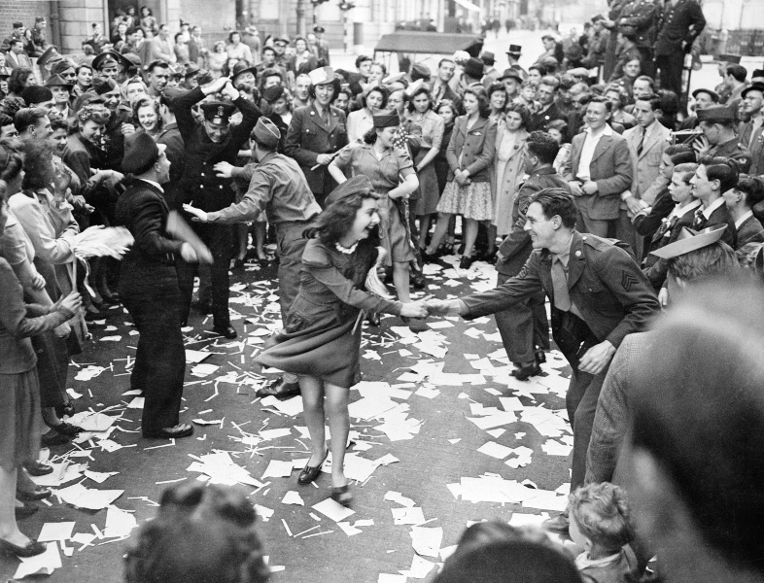
Victory in Europe was marked around the world
The news that the war was over in Europe quickly spread around the world, and people of the British Empire and the Allied countries wanted to celebrate the defeat of Nazi Germany.
In the United States of America, the victory was tempered with the recent death of President Roosevelt, who had led his country through the war years. His successor, Harry S. Truman, dedicated the day to Roosevelt and ordered that flags be kept at half-mast – as part of the 30-day mourning period. Despite this, there were still scenes of great rejoicing in America: in New York, 15,000 police were mobilised to control the huge crowds that had massed in Times Square.
In Australia, the celebrations were also tinged with a sombre mood. The war in the Far East and Pacific was still being fought, and many Australians were serving overseas. But there were scenes of rejoicing in many cities, and services were held in churches around the country to give thanks for the war ending in Europe.
In Paris, huge numbers of people flocked to the centre of the city to celebrate. An eyewitness recalled: ‘On the Champs Elysees they were singing 'It's a Long Way to Tipperary,'…in the Place de la Concorde to the Arc de Triomphe in the Place de l'Etoile, there was hardly any place to breathe and no place at all to move.’
The charged atmosphere and large crowds could lead to unrest. In Halifax, Canada, riots broke out among the large concentration of military personnel stationed there. Thousands of soldiers, sailors and civilians looted liquor stores – which had been closed for the VE Day holiday – and the resulting riots and vandalism resulted in several deaths.

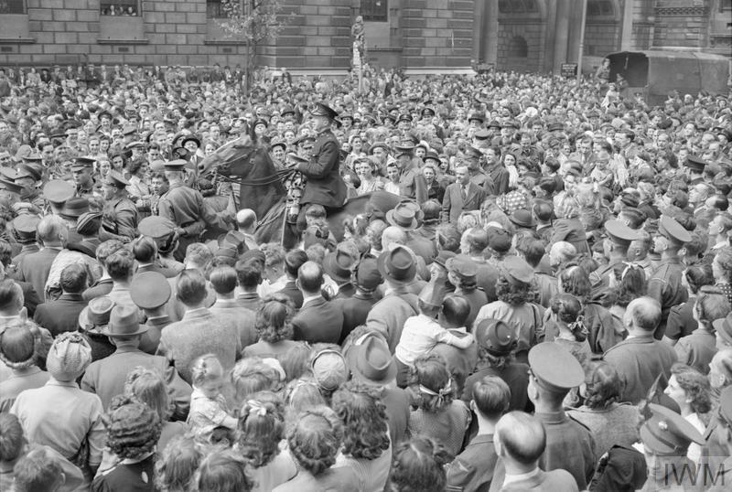
It was a day of mixed emotions
Not everyone celebrated VE Day. For those who had lost loved ones in the conflict, it was a time to reflect. Amidst the street parties and rejoicing, many people mourned the death of a friend or relative, or worried about those who were still serving overseas. For many of the widows the war had produced, the noise and jubilation as people celebrated VE Day was too much to bear and not something they could take part in.
There was also an air of anti-climax. The hardships of the war years had taken their toll on many people and left them with little energy for rejoicing. In Britain, the strain of air raids, the strictures of wartime life and the impact of rationing all left their mark on a weary population who knew there were more difficulties yet to endure.

It was not the end of the war
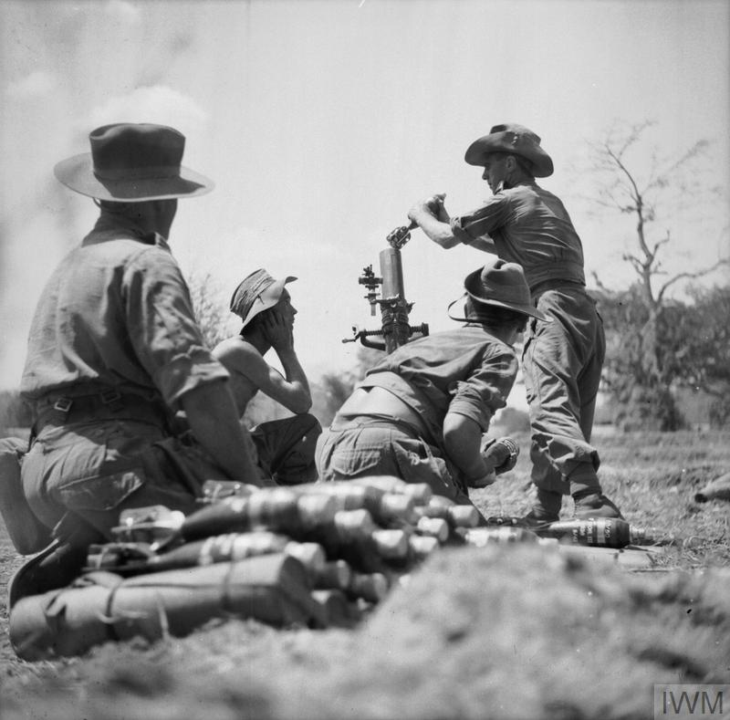
For members of the Allied forces who were still serving overseas on VE Day, the occasion was bittersweet. Although it meant victory in one theatre, the war was not yet over in the Far East and Pacific. The battle conditions there had been some of the toughest of the war. In May 1945, thousands of Allied servicemen were still fighting in the Far East and thousands more were held as prisoners of war in terrible conditions.
The final months of the war in the Pacific saw heavy casualties on both sides, but ultimately ended in victory for the Allies. Japan’s leaders agreed to surrender on 14 August and the act of surrender was signed on 2 September. For people in Britain, the end of the fighting didn’t mean an end to the impact of the war on their lives. Although many things slowly began to return to normal, it took time to rebuild the country and shortages were still felt: clothes rationing lasted until 1949 and food rationing remained in place until 1954. Peace brought its own problems. The huge economic cost of the war resulted in post-war austerity in a practically bankrupt Britain and the far-reaching political effects of the conflict ranged from the fall of the British Empire to the onset of the Cold War.

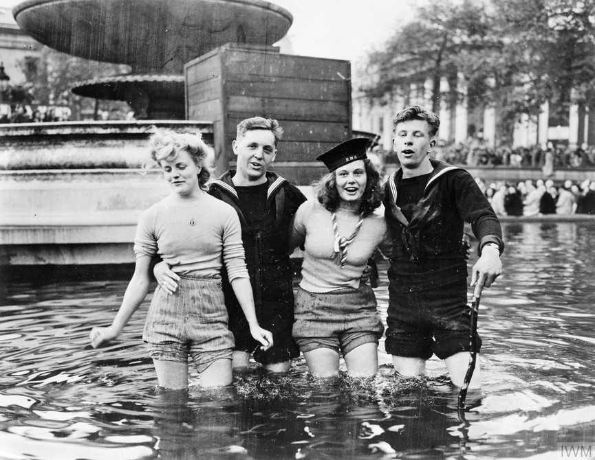
It's an iconic photograph - one that has been used across the world to highlight the celebrations on VE Day, the end of the Second World War in Europe. But there's always been one big question surrounding this particular image: what was the story behind those two women smiling for the camera in the Trafalgar Square fountains on 8 May 1945.
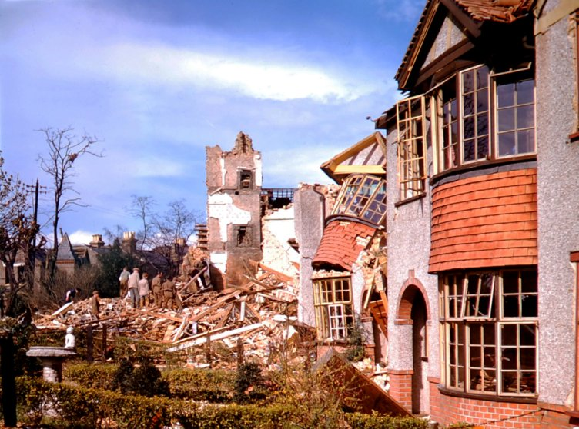
On 7 May 1945 the formal act of military surrender was signed by Germany, ending the war in Europe. The next day celebrations broke out all over the world to mark Victory in Europe or VE Day. In Britain, Churchill marked the occasion by declaring 8 May a public holiday.
On 8 May 1945 millions of people across the world celebrated Allied victory in Europe. But VE Day did not signal an end to the Second World War. Allied servicemen who had fought their way through Europe prepared for their transfer to the Far East and the Pacific, where fighting would continue for three more months.
All over Britain there was still much to do.

